Nazareth Lutheran Church
Website http://nazarethlutheranchurch.yolasite.com/
We welcome all to join us every Sunday!
Worship service @ 10:15 am

Marcia Kisner, Pastor
Eileen Lewis, Administrative Assistant

February 2019

Nazareth Lutheran Church
517 Vine St
PO Box 227
Cambridge IA 50046

From the Pastor
Lent 2019: Let all that you do be done in LOVE. 1 Corinthians 16:14
LOVE! In God’s house…we do second chances…we do grace…we do real…
we do mistakes…we do I’m sorry…we do loud hymns really well…
we do hugs…we do family…we do LOVE!
Beginning with Ash Wednesday on March 6 we will journey through the 2019 Lenten season. We will read and preach the assigned psalms, sing our hymns and say our prayers around our theme of LOVE! The meaning of the name psalm is song. The origin of the name psalm is Hebrew. The book of psalms is a collection of poems, hymns, and prayers.
Ash Wednesday March 7, 2019 Psalm 103.
1st Sunday of Lent March 10 Psalm 91: 1-2; 9-16.
2nd Sunday of Lent March 17 Psalm 27.
3rd Sunday of Lent March 24 Psalm 63: 1-8.
4th Sunday of Lent March 31 Psalm 32.
5th Sunday of Lent April 7 Psalm 126.
We look forward to seeing you this Lenten season. Worship begins at 10:15 am and we invite you to come and find out more about LOVE.

In Our Prayers This Week
Karen Harrelson, Tom, Aloha, Cindy & Dave Dunlap, Greg Leavengood, Shari Kisner, Tracy Christiansen, Beverly Way, Kathleen Erickson, Ashley Reese, Kate Jorgensen, Jessyca Espinoza, Arnie Pearson, Liam Griggs, Don Rhode, Neal Hovland, Ken Larkin, Eva Mae Sampson, Mary Ann Apland, Max Dobson, Scott, John, Janet & Roger Thorsen, &all the Veterans, and active military especially Taylor Bartleson and Jackson Ringgenberg. We lift up our community as we faithfully pray for peace and faith in our country and the world.

February Birthdays
1 Vince Tomlinson 10 Pastor Marcia
11 Mark Lewis 17 Dale Dunlap
27 Lisa Smith
If you wish to have your name added to the birthday list, or if it is
Incorrect, please call Eileen at the office 515-383-4328.

Christian Education:

Intergenerational Sunday School
Sunday school started again in January with many interesting topics and games. We are discussing the books or the bible and reading some of the great stories, like Noah and Sampson and Joseph. The children seem to enjoy learning from the adults and the adults love to see and help the children. Bring your kids and yourself to Sunday school!

Confirmation
Confirmation has also started again after their Christmas break. We are preparing for Confirmation of the students on Easter Sunday. If you know of any young people interested in learning about God and being confirmed, just give us a call at 515-383-4328 with their information and we will get things started!

Weekly Income for December and January
December | Offering | Attendance
12/2 | $ 1,196.00 | 30
12/9 | $ 1,287.00 | 20
12/16 | $ 505.00 | 42
12/23 | $ 1,747.00 | 18
12/24 Christmas Eve | $ 1,021.00 | 44
12/25 Christmas | $ 425.00 | 30
12/30 | $ 230.00 | 17
Total | $ 6,411.00
January | Offering | Attendance
1/6 | $ 2,753.42 | 25
1/13 | $ 385.00 | 23
1/20 | $ 1,060.00 | 21
1/27 | $ 465.00 | 24
Total | $ 4,663.42

Your church needs $5,495.83 monthly to meet budget and does so through your generous giving.

Upcoming Worship Volunteers
February | Greeters/Ushers | Lector | Alter Guild
2/3 | Steve Lewis and Mike Lewis | Kevin L | Joyce A
2/10 | Ray Ringgenberg Family | Maria T
2/17 | Vince Tomlinson Family | Mark L
2/24 | John Egeland and Dave Lewis | Mike L
March | Greeters/Ushers | Lector | Alter Guild
3/3 | Nathan Hovland and Kevin Lewis | Nathan H | Mark L
Ash Wednesday  3/6/2019 | Doug Larkin Family | Ray R | Steve L
3/10 | Mark Lewis and Mava Lewis | Robin S
3/17 | Steve Lewis and Mike Lewis | Steve L
3/24 | Ray Ringgenberg Family | Vince T
3/31 | Vince Tomlinson Family | Wendy R
April | Greeters/Ushers | Lector | Alter Guild
4/7 | John Egeland and Dave Lewis | John E | Wendy R
4/14 | Nathan Hovland and Kevin Lewis | Ellen O | Dale D
Holy Thursday  4/18 | Doug Larkin Family | Eileen L | John E
Good Friday  4/19 | Mark Lewis and Mava Lewis | Multiple readers
Easter Sunday 4/21 | Steve Lewis and Mike Lewis | Joyce A | Mark L
4/28 | Ray Ringgenberg Family | Kevin L

Nazareth Lutheran Church Council

The Annual meeting and a special meeting were called in January, unfortunately the minutes are not available at this time. They will all be in the March Newsletter. I am sorry for the inconvenience.

Mark it down on your calendar!!
For Reservations call the church 515-383-4328 or email Nazareth_lutheranchurch@yahoo.com
Arsenic & Old Lace
By Joseph Kesserling
Friday, March 1, 2019
Performance at 7:30pm
Admission is $10.00

Saturday, March 2, 2019
Dinner served from 6:00pm-7:00pm Performance at 7:30pm
Admission is $20.00

Sunday, March 3, 2019
Matinee at 2pm
Admission is $10.00

Performances will be held at the Cambridge City Center
204 Water Street Cambridge, Iowa
For Reservations call 515-383-4328

Mortimer Brewster is living a happy life: he has a steady job at a prominent New York newspaper, he’s just become engaged, and he gets to visit his sweet spinster aunts to announce the engagement. Mortimer always knew that his family has a bit of a mad gene…his brother believes himself to be Teddy Roosevelt…but his world is turned upside down when he realizes that his dear aunts have been poisoning lonely old men for years. When Mortimer’s maniacal brother, Jonathan (who strangely now resembles Boris Karloff) returns on the night that the aunts were planning to bury the newest victim, Mortimer must rally to help his aunts and protect his fiancé…all the while trying to keep his own sanity

A fundraiser for the newly re-constructed Bell Tower at Nazareth.
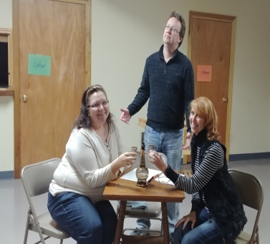
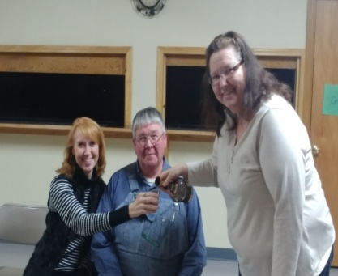
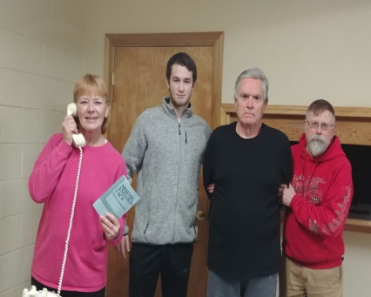

Featuring Abby: Eileen Lewis; The Rev. Dr. Harper: Mark Benson; Teddy Brewster: Greg Romans; Officer Brophy: Nathan Hovland; Officer Klein: Ken Smith; Martha Brewster: Becky Plager; Elaine Harper: Joyce Allen; Mortimer Brewster: Troy Gould; Mr. Gibbs: M. A. Kisner; Jonathan Brewster: Kent Whitemore; Dr. Einstein: Jacob Ervin; Officer O’Hara: Kassandra Olson; Lieutenant Roony: Sheila Duhn; Mr. Witherspoon: John Griffith

Activities for the Month of December and January

Sunday 9:15 AM Sunday School
Feb 3: 10:15 AM Worship

Tuesday
Feb 5: 5:00 PM Food Pantry

Wednesday
Feb 6: 1:30 PM Confirmation

Sunday 9:15 AM Sunday School
Feb 10: 10:15 AM Worship

Tuesday
Feb 12: 5:00 PM Food Pantry

Wednesday
Feb 13: 1:30 PM Confirmation

Sunday 9:15 AM Sunday School
Feb 17: 10:15 AM Worship

Tuesday
Feb 19: 5:00 PM Food Pantry

Wednesday
Feb 20: 1:30 PM Confirmation

Sunday 9:15 AM Sunday School
Feb 24: 10:15 AM Worship

Tuesday
Feb 26: 5:00 PM Food Pantry

Wednesday
Feb 27: 1:30 PM Confirmation

Friday 7:30 PM Arsenic and Old
March 1: Lace at Comm Center

Saturday 6:00PM Dinner seating
March 2: 7:30 PM Play

Sunday 9:15 AM Sunday School
March 3: 10:15 AM Worship
2:00 PM Matinee showing

