Nazareth Lutheran Church
Website http://nazarethlutheranchurch.yolasite.com/
We welcome all to join us
every Sunday!
Worship service @ 10:15 am

Marcia Kisner, Pastor
Eileen Lewis, Administrative Assistant

July 2021

Nazareth Lutheran Church
517 Vine St
PO Box 227
Cambridge IA 50046

From the Pastor

I will give thanks to you, Lord, with all my heart;
I will tell of all your wonderful deeds. Psalm 9:1

Giving thanks to others, saying thank you to others is thanking God. The last few weeks I worked very hard on a project and had the help of others but no one thanked us. I was feeling a little sorry for myself but was reminded by a brother in Christ that we don’t do things for the glory of others but for God’s glory but I still like to hear thank you’s once in a while. So, instead of continuing to feel sorry for myself I went out of my way to thank others in God’s name. Thank you all for the hard word that was done for God’s church in the past few weeks. Thank you for all your prayers. Thank you for all your service.
After thanking many people in God’s name there were two stories on facebook that spoke to me how important Thank you’s are to those in our lives.
A friend went to the grocery store recently and told the woman who was checking out “thank you for all your service during this time of the pandemic.” The checker said, “Wow you are the first person who has taken the time to say thank you. You made my day.” Simple way to help others through a rough time… “thank you.”
Another story, a friend went to physical therapy and while there thanked the therapist. He also said, “Wow, you are the first person who has taken the time to say thank you. You made my day.” Again, words like thank you can be so uplifting and can bring God’s love into other’s lives.
Every day give thanks to God and along the way give thanks to others.
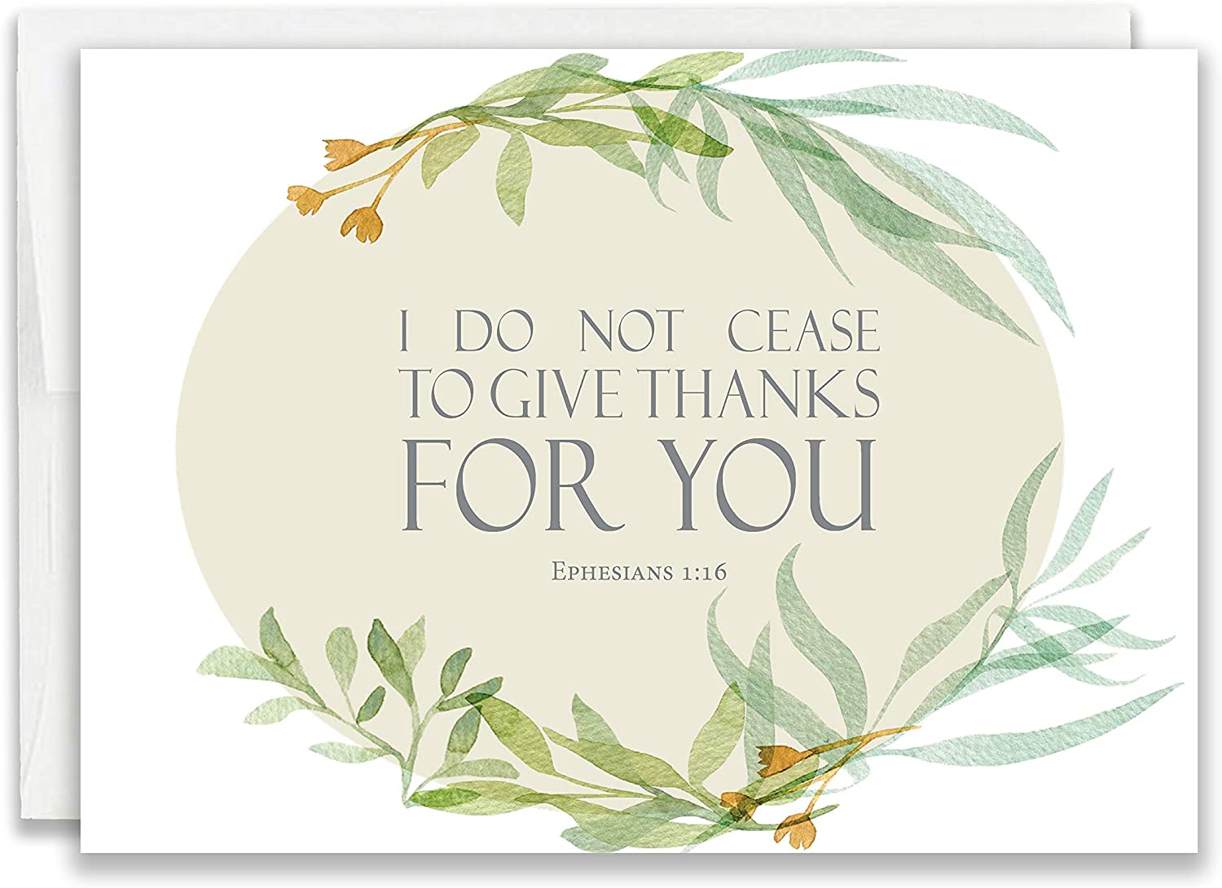
Peace,
Pastor Marcia

In Our Prayers This Month

All the people of the world as COVID-19 threaten.
All people with cancer, Polly Wilson, Ken Bauge, Allan Duhn, Pastor Melisa Bracht-Wagner, Nancy Reed, Paul Egeland, Vince Tomlinson, Tim Smith, Brandon Sorenson, Mike Peterson, Jean Olson, Tim Barker, Lori Ness, Shari Kisner, Liam Griggs, Neal Hovland, Mary Ann Apland, Scott, John, Janet & Roger Thorsen,

And all Veterans, & active military especially Drayke & Dylan Eshelman, Jacob Morgan, Taylor Bartleson, Alex Kuberry, Jackson and Winter Ringgenberg.

Vacation Bible School

We are once again partnering with Cambridge Methodist Church to do Vacation Bible School. It will be the week of July 19th - 23rd. The theme this year is “Back to Basics”.
The plan is to serve a light supper from 5:30 to 6:00 pm each evening, and then we will have bible story, craft and games each night from 6:00 to 7:30. We will have music and learn some new songs. On Friday July 23rd we encourage the families of the children to stay to listen to the songs and the stories that we learned.
If you would like to help with VBS there is a planning meeting on July 7th at 6:30 at the Methodist church. We are looking for people to help with the crafts and the games as well as the light supper. We would also appreciate donations to cover the cost of the food and supplies.

Pastor’s Vacation

Pastor Marcia will be on vacation from Thursday July 8 through Sunday July 11, she will not be here for worship. We may have a hymn sing or something. Any suggestions??
She will then be gone Monday August 2 to Friday August 6th but will be back for worship. She and her friends are going to watch baseball (on TV because tickets are too expensive).
Finally there is a Continuation Education retreat on August 9 and 10th that Pastor Marcia will be at. If you need her you may call her cell phone, 515-215-0609, or call Eileen Lewis at 515-491-8927

Income Report

May | Offering | Attendance
5/2 | $ ,413.00 | 15
5/9 | $ 684.00 | 16
5/16 | $ 240.00 | 17
5/23 | $ 855.00 | 15
5/30 | $ 590.00 | 16
Total | $ 4,782.00
June | Offering | Attendance
6/6 | $ 1,432.00 | 18
6/13 | $ 625.00 | In the Park
6/20 | $ 860.00 | 19
6/27 | $ 210.00 | 18
Total | $ 2,917.00

The church needs $5,604.17 monthly to meet budget and does so through your generous giving.

July and August Birthdays
1 Jordan Aust
2 Doug Larkin
2 John Egeland
4 Richard Ness
6 Bill Hook
8 Lilli Hasbrouck
9 Ellen Olson
26 Jason Hasbrouck
28 Becca Hasbrouck
31 Joan Weatherman
1 Jordan Aust
2 Doug Larkin
2 John Egeland
4 Richard Ness
6 Bill Hook
8 Lilli Hasbrouck
9 Ellen Olson
26 Jason Hasbrouck
28 Becca Hasbrouck
31 Joan Weatherman

2 Doug Larkin 2 John Egeland
4 Richard Ness 6 Bill Hook
8 Lilli Hasbrouck 9 Ellen Olson
16 Audrey Leiber 25 Adam Leiber
26 Jason Hasbrouck 28 Becca Hasbrouck
31 Joan Weatherman
August
10 Ray Ringgenberg 18 Jessie Hovland 29 Skylar Kelly

Please call Eileen at the church office, 515-383-4328 to let her know if you know of a birthday that is missing or incorrect.

Nazareth Lutheran Church Council
Sunday, June 20, 2021

Meeting was called to order at 11:21 by President Mark Lewis following worship. Present for the meeting were Mark Lewis, John Egeland, Lisa Smith, Dave Lewis, Vince Tomlinson, Pastor Marcia, Joyce Allen, and Church Administrator Eileen Lewis. Minutes from the May meeting were approved as read, with the correction that it was the Methodist church’s VBS committee that wanted to host this year, not the pastor.

Treasurers Report: The General Fund opened the month with $9,813.22. Deposits amounted to $25,910.09, including donations towards the farm sale ($214.38) and silent auction (71.33). $842.38 was made from the farm sale, and $20,000 was transferred from the Capital Improvement Fund to cover the Hedrick repairs thanks to the derecho. Disbursements subtracted $31,738.24. Besides the every-month utilities and salaries, $225.00 bought a new refrigerator at the parsonage, $746.18 was donated to the Duhns, and $25,782.98 was paid to Hedrick. We will be getting back $647.74 as an insurance adjustment. Capital Improvement stands at $27,745.80 in spite of transferring $20K, and Missions’ balance is $9,727.14. SCRIP opened the month with a balance of $962.65, and closed at $891.45, after deposits of $703.80, and disbursements totaling $775.00.

Pastor’s Report: Visits continue, and work on the parade and silent auction were well worth the work. There were 144 entrants in the parade this year, and hand-outs of fire-extinguisher squirt guns, fireman badges and hats were handed out to children along the route. VBS is in the planning stages, with daily themes and songs selected. Pastor has requested vacation dates for July 9-12, August 2-6, and a Continuing Ed retreat August 9 and 10, where preparation for Advent will be discussed. She will be presiding over a wedding for Heather Roberts and Brad on August 21 at the Community Center. Lastly, Bishop Birchmeyer will be visiting for worship on July 25, with a luncheon to follow. Invites to parishioners will be mailed out two weeks prior.

Committee Reports:
Property: Alliant Energy will be trenching in the easement along the church’s property line on Vine St. sometime in the near future.
Christian Ed: VBS will be held July 19-23. Time will be 5:30 – 6:00 for light dinner, and school from 6:00 – 7:30 instead of 8:00. Volunteers needed, please!
Stewardship: Nothing to report
In reach / outreach: Nothing to report
Music and Worship: Hymn selection runs out 7/11/21.

Old Business: The silent auction went well! Helped be well-organized, and taking goods to Dorcas on Thursday instead of Friday. Suggestions for next year include putting a sign in the window at Dorcas so people know the auction’s times, putting up flyers around town, and including a breakfast. Discussion given as to where it should be held, but that decision will be made closer to the appointed time.

New Business: Nothing to report

There being no further business, meeting was adjourned at 12:04 by President Mark Lewis, and closed with The Lord’s Prayer.
Respectfully submitted by Joyce Allen, Council Secretary

Upcoming Worship Volunteers

July | Greeters/Ushers | Lector | Alter Guild
7/4 | Vince | Nathan | Kevin
7/11 | Dave | Dave | Lisa
7/18 | Doug | Doug | Mark
7/25 | John | Vince | Mike
August | Greeters/Ushers | Lector | Alter Guild
8/1 | Kevin | Wendy | Nathan
8/8 | Mark | Eileen | Steve
8/15 | Mike | Ellen | Vince
8/22 | Nathan | John | Wendy
8/29 | Ray | Joyce | Dale
September | Greeters/Ushers | Lector | Alter Guild
9/5 | Steve | Mark | Jessica
9/12 | Vince | Mike | John
9/19 | Dave | Nathan | Joyce
9/26 | Doug | Ray | Kevin

Thank You for volunteering!! “The smallest act of kindness is worth more than the grandest intention.” – Oscar Wilde

Activities for the Month of July and August
**No newsletter For August

Sunday 9:15 Adult Sunday School
July 4: 10:15 AM Worship

Tuesday
July 6: 6:00 PM Food Pantry

Sunday 9:15 Adult Sunday School
July 11: 10:15 AM Worship

Tuesday
July 13 6:00 PM Food Pantry

Sunday
July 18: 10:30 AM Worship in Park

Monday – Friday at Methodist Church
July 18-23 5:30 PM Vacation Bible School

Tuesday
July 20: 6:00 PM Food Pantry

Sunday 9:15 Adult Sunday School
July 25: 10:15 AM Worship

Tuesday
July 27: 6:00 PM Food Pantry

Sunday 9:15 Adult Sunday School
August 1: 10:15 AM Worship

Tuesday
August 3: 6:00 PM Food Pantry

Sunday 9:15 Adult Sunday School
August 8: 10:15 AM Worship

Tuesday
August 10: 6:00 PM Food Pantry

Sunday 9:15 Adult Sunday School
August 15: 10:15 AM Worship

Tuesday
August 17: 6:00 PM Food Pantry

Sunday 9:15 Adult Sunday School
August 22: 10:15 AM Worship

Tuesday
August 24: 6:00 PM Food Pantry

Wednesday
August 25: First day of School

Sunday 9:15 Adult Sunday School
August 29: 10:15 AM Worship

Tuesday
Aug 31: 6:00 PM Food Pantry

