Nazareth Lutheran Church
Website http://nazarethlutheranchurch.yolasite.com/
We welcome all to join us every Sunday!
Worship service @ 10:15 am

Marcia Kisner, Pastor
Eileen Lewis, Administrative Assistant

November 2018

Nazareth Lutheran Church
517 Vine St
PO Box 227
Cambridge IA 50046

From the Pastor

"'You must love the LORD your God with all your heart, all your soul, all your strength, and all your mind.' And, 'Love your neighbor as yourself.'"
Luke 10:27

Eleven people were killed at a Pittsburgh synagogue. The gunman did so because he hated the worshippers of that synagogue. I found out about the shooting while working at the Center Grove Apple Orchard by a woman in her 80’s.
She and her family had come to the orchard to enjoy each other and the beautiful day. She told me she and her husband came up north from Missouri to spend time with some of their children. She and her husband were dressed as Dorothy and the Scarecrow from The Wizard of Oz, their family was dressed as the Incredibles, and of course the young girls were Elsa and Anna.
I sat with them for a few minutes to talk. She shared her and her family always enjoyed dressing up during Halloween and spending time together. She and her husband laughed and joked with people as they came up to them to say how wonderful their costumes were and how fun to see them. She asked about the Apple Orchard and I gave them a tour from the bench. She asked if I did this all year long. I told her that I was a pastor at a church in a small town 3 miles from the orchard.
The conversation turned serious. She asked if I had heard about the horrific shooting at the synagogue. I said no and she shared with me about the shooting. She didn’t know how many were killed at that time but she looked around and told me that we need more places like the orchard to enjoy each other, to laugh together, and yes, even to learn to love spending time together. We needed to stop hating. Just like she and her husband and I were sharing our lives at this moment we were learning about each other and sharing our lives.

I never got their names but she was a wonderful preacher on that crisp sunny Saturday morning. I ask God to continue to bless this beautiful woman and her husband as they continue to spread a message of love throughout their travels. I thank God for her sharing this horrible news because it was shared with deep sorrow and prayerfully. And it most certainly reminded me of Hebrews 13:2 …
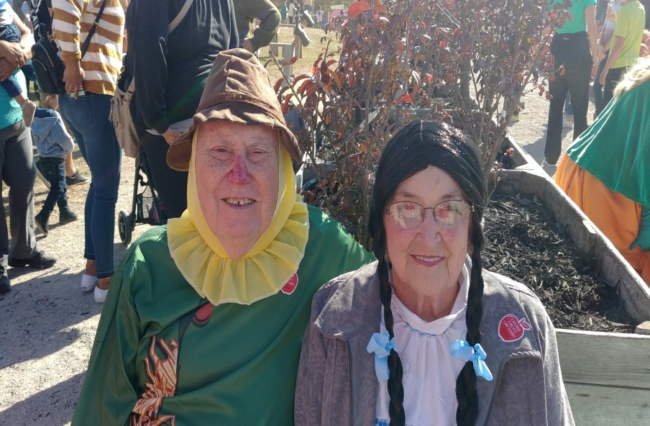
“Do not neglect to show hospitality to strangers, for by doing that
some have entertained angels without knowing it.”
In Our Prayers This Week
Greg Levengood, family and friends of Matthew Cox, Scott and John Thorson, Greg Dunlap, Shari Kisner, Tracy Christiansen, Beverly Way, Kathleen Erickson, Ashley Reese, Kate Jorgensen, Jessyca Espinoza, Arnie Pearson, Alan Duhn, Liam Griggs, Don Rhode, Neal Hovland, Ken Larkin, Eva Mae Sampson, Mary Ann Apland, Dorothy Denton, Max Dobson, Janet & Roger Thorsen, and all the military especially Taylor Bartleson and Jackson Ringgenberg. We lift up our community as we faithfully pray for peace and faith in our country and the world.

November Birthdays
5 Don Rohde 6 Teenie Tomlinson

If you wish to have your name added to the birthday list, or if it is
Incorrect, please call Eileen at the office 515-383-4328.

Christian Education:

Intergenerational Sunday School
Mava told me the other day that I shouldn’t kill a fly that was buzzing around the house. She told me she learned in Sunday school that Jesus is in all the living creatures and all around us. Wow! Sometimes it’s easy to learn about God when you have an open heart. Come and find out how the young ones teach the old ones.

Confirmation
Confirmation at 1:30 -3:00 PM is working out really well! We are getting back into the swing of studying. We went to the Apple Orchard in October and found some interesting things that we will be talking about in upcoming weeks. It is not too late if you know of any young people interested, just give us a call at 515-383-4328 with their information and we will get things started!

Adult Bible Study
Well, in case you haven’t noticed Adult Bible Study hasn’t started yet. There have been al kinds of conflicts and last minute things that have come up that have interfered. However we are hoping to start on Wednesday November 7th at 6:30 PM at Church. We will begin with the book “Why?: Making Sense of God’s Will By Adam Hamilton.

Weekly Income for October
September | Offering | Attendance
9/2 | $ 1,075.00 | 8
9/9 | $ 452.00 | 23
9/16 | $ 396.52 | 18
9/23 | $ 696.00 | 18
9/30 | $ 340.00 | 28
Total | $ 2,959.52
October
10/7 | $ 1,397.00 | 27
10/14 | $ 406.69 | 21
10/21 | $ 2,356.47 | 20
10/28 | $ 270.00 | 23
Total | $ 4,430.16

Your church needs $5,425.00 monthly to meet budget and does so through your generous giving.

Upcoming Worship Volunteers
November | Greeters/Ushers | Lector | Alter Guild
11/4 | Steve Lewis and Mike Lewis | Joyce A | Joyce A
11/11 | Ray Ringgenberg Family | Kevin L
11/18 | Vince Tomlinson Family | Maria T
11/25 | John Egeland and Dave Lewis | Mark L | Mark L
December | Greeters/Ushers | Lector | Alter Guild
12/2 | Nathan Hovland and Kevin Lewis | Mike L | Steve L
12/9 | Doug Larkin Family | Nathan H
12/16 | Mark Lewis and Mava Lewis | Ray R
12/23 | Steve Lewis and Mike Lewis | Robin S
12/24  Christmas Eve | Vince Tomlinson Family | Steve L | John E
12/25  Christmas Day | John Egeland and Dave Lewis | Ellen O | Wendy R
12/30 | Nathan Hovland and Kevin Lewis | John E
It looks like it is time to start making a new calendar for Worship Volunteers. Please let Eileen know if you want to change your commitment to volunteering.

Mark it down on your calendar!!
Nazareth Lutheran Church will be hosting Dinner and a Play again March 1st, 2nd and 3rd. More info to come, but start making your plans now to come and enjoy the evening!

CONGREGATIONAL MEETING
NAZARETH LUTHERAN CHURCH
SUNDAY, SEPTEMBER 30, 2018

Meeting was called to order at 11:10 by President Mark Lewis, with 28 parishioners in attendance. Topic of this meeting was to discuss how to best correct a problem with a leaking pipe that was draining onto a neighbor’s property, causing standing water in his yard. Discussion given as to who owns the property where the leaky pipe is.
Possibilities to remedy the problem included fixing the tile east of the church, or redirecting the sump pump pipe. No estimate has been made as to how much it would cost to fix it. The city owns the property to the East, but gave the church easement.
Motion made by Steve L. to redirect the sump pump water to the storm sewer by Ray Street, West of the church, seconded by John. Discussion given to cap off the tile, or if there is another storm sewer to use for drainage.
Amendment motion made by Ellen that we cap the tile going East, and drain to a closer sewer line if available, seconded by Joyce. Motion carried, meeting adjourned at 11:19 by President Mark Lewis.
Respectfully submitted by
Joyce Allen, Council Secretary.

Nazareth Lutheran Church Council Meeting
Sunday, October 21, 2018

Meeting was called to order at 11:28 by President Mark Lewis. Present for the meeting were Mark Lewis, Dave Lewis, Steve Lewis, John Egeland, Pastor Marcia, Joyce Allen and Church Secretary Eileen Lewis. Minutes from the September 16 Council Meeting and September 30 Congregational Meeting were approved as read.

Treasurer’s Report: Lisa Smith was not present for the meeting, but issued a statement that the General Fund was overdrawn. She apologized for not noticing the balance sooner and avoiding the error by transferring funds in time, and said she would take care of the overdraft fees herself since it was her error.
Pastor Marcia made a motion that NLC take care of these fees, not Lisa, seconded by John, and motion carried. General Fund balance on 9/1/80 was $1,215.30. Deposits totaled $3,250.97, disbursements came to $4,699.24, leaving a balance of $232.97 in the red. Capital Improvement balance has $9,673.93, and Mission Investment is at $9,517.44. SCRIP’s balance on 9/1 was $1,220.35, with $900 in deposits and $910.45 in disbursements, leaving a balance of $1,209.90. Not sure where the funds, or how much, were transferred into the General Fund at this point in time.

Pastor’s Report: Confirmation class is going well, but Pastor feels a lesson on gratitude and being thankful is in order at the next meeting, teens being teens. Adult Bible study hasn’t begun yet due to hours at the Orchard, but will be starting soon since the Orchard will be closing for the season.
An adult VBS was held at Ballard Creek, and was very well received. On Friday, October 5, Pastor and about twelve “students” met, enjoyed Bible lessons, crafts, lunch, and lots of singing. It ended with members of the group sharing miracles they’ve seen or experienced. One lady shared being a four time cancer survivor, another talked about a very serious auto accident where no one was hurt. She looks forward to doing it again next year.

Committee Reports:
Property: Nothing to report
Christian Ed: See Pastor’s Report
Stewardship: Nothing to report
In reach/outreach: October 28 is Invite a Friend Sunday
Music and Worship: Nothing to report

Old Business: Nothing to report

New Business: Lisa wanted to know if we want to keep the Pastor’s insurance the same as it has been since it was time for renewal. Yes, it will be kept the same. Discussion was then given to start planning for the next play to be done at the Community Center, again the first weekend in March 2019. Since the rights for the show haven’t been obtained yet, a formal announcement of the play can’t be made public yet, but Joyce will obtain the rights this week.

There being no further business, the meeting was adjourned at 11:57 by President Mark Lewis, and closed with the Lord’s Prayer.
Respectfully submitted by
Joyce Allen, Council Secretary.

Activities for the Month of November

Sunday 9:15 AM Sunday School
Nov 4: 10:15 AM Worship

Tuesday
Nov 6: 5:00 PM Food Pantry

Wednesday 1:30 PM Confirmation
Nov 7: 6:30 PM Bible Study

Saturday
Nov 10: 9:00 AM Lefsa Making

Sunday 9:15 AM Sunday School
Nov 11: 10:15 AM Worship

Tuesday
Nov 13: 5:00 PM Food Pantry

Wednesday 1:30 PM Confirmation
Nov 14: 6:30 PM Bible Study

Saturday 9:00 AM – 2:00 PM
Nov 17: Shopping Extravaganza

Sunday 9:15 AM Sunday School
Nov 18: 10:15 AM Worship

Tuesday
Nov 20: 5:00 PM Food Pantry

Wednesday 1:30 PM Confirmation
Nov 21: 6:30 PM Bible Study

Thursday
Nov 22: Happy Thanksgiving

Sunday 9:15 AM AM Sunday School
Nov 25: 10:15 AM Worship

Tuesday
Nov 27: 5:00 PM Food Pantry

Wednesday 1:30 PM Confirmation
Nov 28: 6:30 PM Bible Study

Sunday 9:15 AM AM Sunday School
Dec 2: 10:15 AM Worship

Lefsa and Kringla

Nazareth will again be selling Lefsa and Kringla at the Shopping Extravaganza on November 17 at the Cambridge Community Center. You can order it now and pick it up then or you can order it then for later pick up.
If you are going to order now please give us a call at the church and leave a message with you name, phone number, and your order. The number is 515-383-4328 or email us at Nazareth_lutheranchurch@yahoo.com again we will need you name, phone number and how many lefsa and kringla you want to order.

Do you want to learn the age old method of making lefsa please come by the church basement on November 3rd or the 10th. We will be making those night and we would love to show you how to make it.

Christmas Shopping Extravaganza
Saturday Nov 17th from 9:00 AM to 2:00 PM at the Cambridge Community Center
Christmas goodies and early shopping with many vendors such as Cowman Creations, Paparazzi Jewelry, Thirty One Gifts, Norwex, Young Living, Mike’s Coffee, Pampered Chef, Tupperware, Mary Kay, Pam’s Jams, LulaRoe, Whimsical Wine Trailer, Korkin Krazy Hair Bows, Small Town Maskcara, Scentsy, Cottage by the River Jewelry, At Home Wine Parties and more!! Lunch will be available also!
~~~~~~~~~~~~~~~

