Nazareth Lutheran Church
Website http://nazarethlutheranchurch.yolasite.com/
We welcome all to join us every Sunday!
Worship service @ 10:15 am

Marcia Kisner, Pastor
Eileen Lewis, Administrative Assistant

October 2019

Nazareth Lutheran Church
517 Vine St
PO Box 227
Cambridge IA 50046

From the Pastor

¹⁵ No one after lighting a lamp puts it under the bushel basket, but on the lampstand, and it gives light to all in the house. ¹⁶ In the same way, let your light shine before others, so that they may see your good works and give glory to your Father in heaven. Matthew 5:15-16

Who are we as a church? What is our passion as we serve God and God’s people? For the past several years we have boldly gone where our church has not gone before. I know a reference to Star Trek isn’t very “religious” but I want us to continue finding new ministries to serve God and share the gospel message of Jesus Christ.
We have found several new ministries in the past few years that we can help. One ministry is sharing our monetary gifts with people who go on mission trips to help people. Last summer we were able to raise enough money to purchase 17 pair of leather shoes for students in Tanzania who attended a school but had no shoes. We were also able to find someone there to make the shoes.
The Silent Auction we do every year at the “Fireman’s Days” has grown and helped not only our church (it helps pay our yearly insurance) but the Volunteer Fire Department and the local Food Pantry. The part of the money going towards the insurance does not seem like a very glamorous mission, but we continue to be good stewards of God’s church. As you all know from your own property taxes and bills costs have sky rocketed. We raised almost $3000 at the Silent Auction but our insurance bill went to almost $5000.
Speaking of being a good steward of God’s church property we had our second annual play and dinner in March of this year. The money went to the refurbishment of the bell tower. The cost of the tower was almost 20,000 so it will be a few years before we are able to replenish the building fund. We were very blessed to have the money available to take care of the bell tower. Again not a glamorous ministry but at Christmas when the candles light up our church and street in Cambridge I praise God for the beauty of the building.
Another ministry we happened upon was “Feel Better Friends.” Feel Better Friends are handmade dolls stuffed with love and well wishes, crafted by volunteers and donated to children battling cancer and other illnesses. In May of 2014 Shanon Fouquet, artist and designer from Shanonigans, came up with the idea when she saw a picture of a little girl named Berkeley who was battling cancer and holding her American Girl doll.

Like most little girls who have this popular doll, Berkeley was “twinning”, or dressed identically to her doll. Shanon looked at this particular photo of this brave little girl who was proud to be going ‘wigless’ to her doctor’s appointment that day, and Shanon couldn’t help but wonder if Berkeley would like for her doll to be able to go ‘wigless’ too. It was then that Shanon decided to come up with a handmade doll created just for Berkeley with a wig and matching clothes that could go ‘wigless’ just like her!

Shanon had so much fun making Berkeley’s doll that she decided to make more dolls for other children suffering from cancer and other illnesses, who would like the comfort of a Feel Better Friends doll custom made with their own likeness and characteristics. It was then that the FBF project was started and quickly grew and soon there were enough children wanting FBF dolls that Shanon couldn’t keep up. She started a volunteer group of other crocheters who wanted to give just like Shanon.

Now with almost 200 volunteers across the US and some in other countries, there are children all around the world receiving the love and comfort of their very own FBF dolls. You can find out more about the Feel Better Friends project at https://fbfdolls.org/.
We also play a small role in the Back Pack Buddies program here in our area. There are members who monthly donate funds or food to this program. It helps feed students who are going hungry.
So, who are we as God’s church in this community? How do we serve each other and God? We need your help in coming up with more ideas for ministry. Several months ago one of the church council members thought we needed to visit our shut-in’s so we began Traveling Fellowship. This member makes Kringla so he always takes some to share with our members. Where is your passion for sharing the good news of Jesus Christ? Please join us on Sunday morning to begin sharing our ministry together.
Love, Pastor Marcia

In Our Prayers This Month
John Leoni, Mitch Piecher, Tim Barker, Joanell Koster, Dale Dunlap, Amy Chapin, Jaylee Ann Bartleson, Lori Ness, Shari Kisner, Jessyca Hovland, Arnie Pearson, Liam Griggs, Don Rhode, Neal Hovland, Eva Mae Sampson, Mary Ann Apland, Max Dobson, Scott, John, Janet & Roger Thorsen, all the Veterans, and active military especially Taylor Bartleson and Jackson Ringgenberg.
We lift up our community as we faithfully pray for peace and faith in our country and the world.

Weekly Income for August and September
August | Offering | Attendance
8/4 | $ 1,559.00 | 21
8/11 | $ 445.00 | 7
8/18 | $ 635.00 | 18
8/25 | $ 1,035.00 | 29
Total | $ 3,674.00
September | Offering | Attendance
9/1 | $ 975.00 | 7
9/8 | $ 1,192.00 | 18
9/15 | $ 1,336.11 | 22
9/22 | $ 719.00 | 20
9/29
Total | $ 4,222.11

Your church needs $5,495.83 monthly to meet budget and does so through your generous giving.

Nazareth Lutheran Church Council
There was not a Council meeting in September due to the activities on Rally Sunday.

October Birthdays
1 Jordan Aust
2 Doug Larkin
2 John Egeland
4 Richard Ness
6 Bill Hook
8 Lilli Hasbrouck
9 Ellen Olson
26 Jason Hasbrouck
28 Becca Hasbrouck
31 Joan Weatherman
1 Jordan Aust
2 Doug Larkin
2 John Egeland
4 Richard Ness
6 Bill Hook
8 Lilli Hasbrouck
9 Ellen Olson
26 Jason Hasbrouck
28 Becca Hasbrouck
31 Joan Weatherman

3 Mike Lewis
5 Kevin Bartleson
10 Mary Ann Apland
14 Alanna Dubberke
24 Kelsey Bartleson
28 Janis Hovland
Please call Eileen at the church office, 515-383-4328 to let her know if you know of a birthday that is missing or incorrect.
Disney on Ice Raffle
Wells Fargo donated 4 “Disney on Ice” tickets for the Silent Auction, unfortunately they were 2 weeks late. The tickets are for Sunday December 1st. So we will be raffling the tickets off.
If you are interested the tickets are $1.00 per ticket or 6 tickets for $5.00. Contact the church to purchase a ticket, email nazareth_lutheranchurch@yahoo.com, call 515-383-4328, or talk to a church council member.
The drawing for the raffle will be November 16th during the Cambridge Christmas extravaganza. Please make sure we have your phone number so we can contact you when you win!

Life Events celebrated by the Nazareth faith community this month:
- Ashley Kalkas, Dale and Greg Dunlap’s granddaughter, hcelebrated the birth of Ayvanna Jo, bonr on September 11th.
- Juli and Ben Sharpnack celebrated the birth of their daughter Remiah Jo on September 24th. Juli is the daughter of Nathan and Janis Hovland.
- Larry Hovland, Nathan’s brother, fell off a ladder and has suffered some sever e injuries.
- Greg and Dale Dunlap participated in a Celebration of Life for Greg’s parents Tom and Aloha Dunlap who have passed away in this past year.
- Joanell Koster has moved to a nursing home temporarily to recover from a severely sprained knee. Joanell is Eileen Lewis’ mother.

Upcoming Worship Volunteers

October | Greeters/Ushers | Lector | Alter Guild
10/6 | John Egeland and Dave Lewis | Wendy R | Sheila D
10/13 | Nathan Hovland & Kevin Lewis | Eileen L | Jessica L
10/20 | Doug Larkin Family | Ellen O | JoLynn L
10/27 | Mark Lewis and Mava Lewis | John E | Jazmine M
November | Greeters/Ushers | Lector | Alter Guild
11/3 | Steve Lewis and Mike Lewis | Joyce A | Wendy R
11/10 | Ray Ringgenberg Family | Kevin L | Vince T
11/17 | Vince Tomlinson Family | Vince T | Dale D
11/24 | John Egeland and Dave Lewis | Mark L | Joyce A
December | Greeters/Ushers | Lector | Alter Guild
12/1 | Nathan Hovland & Kevin Lewis | Mike L | John E
12/8 | Doug Larkin Family | Nathan H | Kevin L
12/15 | Mark Lewis and Mava Lewis | Ray R | Lisa S
12/22 | Steve Lewis and Mike Lewis | Robin S | Mark L
12/24/2019 | Vince Tomlinson Family | Steve L | Nathan
12/25/2019 | John Egeland and Dave Lewis | Ellen O | Steve L
12/29 | Nathan Hovland & Kevin Lewis | John E | Mark L
January | Greeters/Ushers | Lector | Alter Guild
1/5 | Doug Larkin Family | Nathan H | Mike L

Activities for the Month of October

Tuesday
Oct 1: 5:00 PM Food Pantry

Saturday
Oct 5: 9:00 AM Kringla Class

Sunday 9:30 AM Sunday School
Oct 6: 10:15 AM Worship

Tuesday 3– 7 PM Blood Drive at Palestine Lutheran Church
Oct 8: 5:00 PM Food Pantry

Sunday 9:30 AM Sunday School
Oct 13: 10:15 AM Worship

Tuesday
Oct 15: 5:00 PM Food Pantry

Saturday
Oct 19: 9:00 Lefsa Class

Sunday 9:30 AM Sunday School
Oct 20: 10:15 AM Worship

Tuesday
Oct 22: 5:00 PM Food Pantry

Saturday
Oct 26: 9:00 Lefsa Class

Sunday 9:30 AM Sunday School
Oct 27: 10:15 AM Worship

Tuesday
Oct 29: 5:00 PM Food Pantry

Notes…
- Raffle tickets for Disney on Ice are on sale. The Raffle tickets are on the back table in church along with an envelope for the money. Tickets are 1 for $1 or 6 for $5. Or you can send a check to church and the information to add to the ticket. The tickets are or December 1st and the winner will be drawn during the Shopping Extravaganza.
- Our annual fall Kringla and Lefsa Sale is coming to the Shopping Extravaganza on November 23rd, at the Cambridge City Center. so we will be making Lefsa and Kringla for sale.
- We will have kringla classes on Saturday September 28 and October 5 both days at 9:00 am. Come for one or both days.
- Lefsa classes will be October 19, October 26, November 2 and November 9th. Each day at 9:00 am. Come for as many days as you would like.
- The church has a bunch of scratch paper, or “art paper” for the little ones if anyone let Eileen know at church.
- Back Pack Buddies item for October is Granola bars. Please contact Rhonda Ceynar 383-2246 to drop off your items.
- Sheldahl United Methodist Women invite all to their Fall Festival on October 19th. There will be a chicken and noodle dinner as well as craft and bakes ale items to purchase.
- Write down the Scandinavian Coffee on your calendar for Saturday November 2nd at Bethesda Lutheran Church of Ames

Puzzle Time!
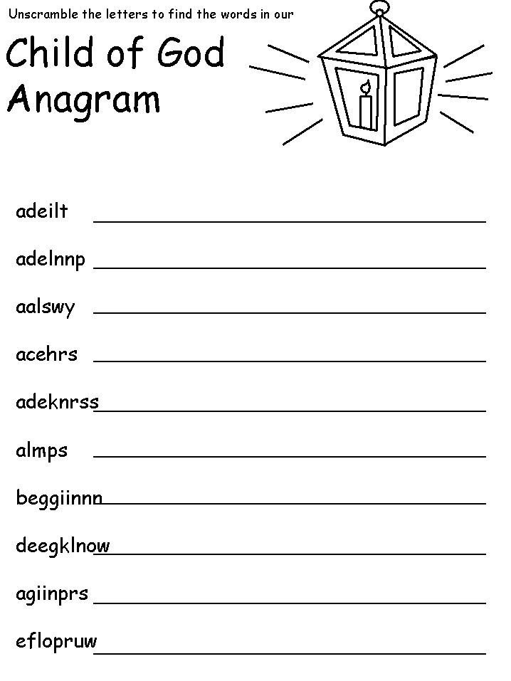
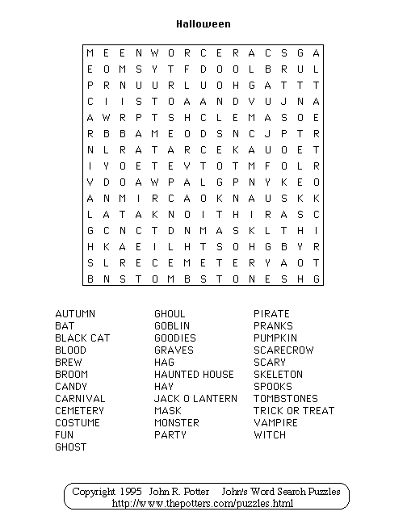

FORGIVENESS CRYPTOGRAM
A | B | C | D | E | F | G | H | I | J | K | L | M | N | O | P | Q | R | S | T | U | V | W | X | Y | Z

__ | __ | __ |  | __ | __ | __ | __ |  | __ | __ | __ |  | __ | __ | __ | __ | __
14 | 2 | 26 |  | 11 | 26 | 25 | 18 |  | 10 | 25 | 3 |  | 3 | 26 | 22 | 26 | 12

__ | __ | __ | __ | __ | __ | __ | . |  | __ | __ | __ | __ | __ | __ | __ | __ | __ | __ | __ |  | __ | __
6 | 13 | 12 | 21 | 17 | 22 | 26 |  |  | 6 | 13 | 12 | 21 | 17 | 22 | 26 | 3 | 26 | 19 | 19 |  | 17 | 19

__ | __ | __ |  | __ | __ | __ | __ | __ | __ | __ | __ | __ |  | __ | __ |  | __ | __ | __
14 | 2 | 26 |  | 25 | 14 | 14 | 12 | 17 | 7 | 9 | 14 | 26 |  | 13 | 6 |  | 14 | 2 | 26

__ | __ | __ | __ | __ | __ | .
19 | 14 | 12 | 13 | 3 | 21

